Jupyter Notebooks Essentials

- In VSCode go to the tab “File” > “New File”. You will get a prompt in the middle of the screen. Select the option “Jupyter Notebook.”
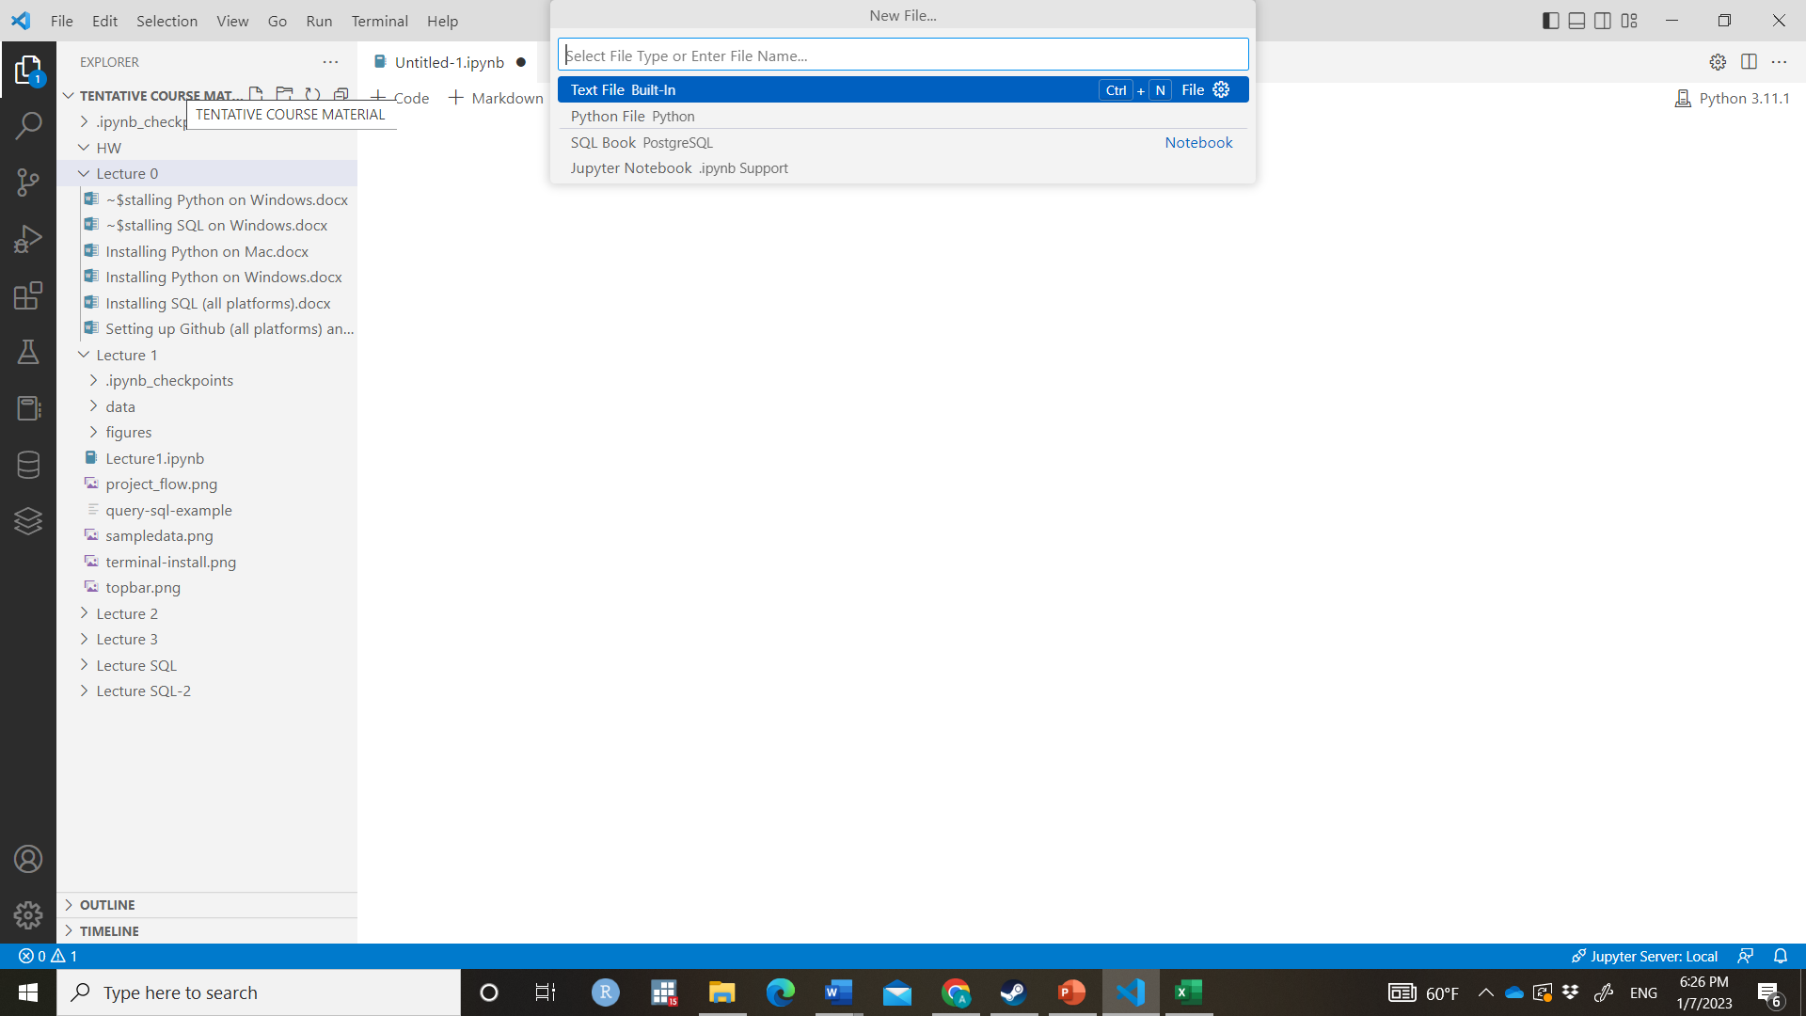
- An empty Jupyter notebook looks something like this:
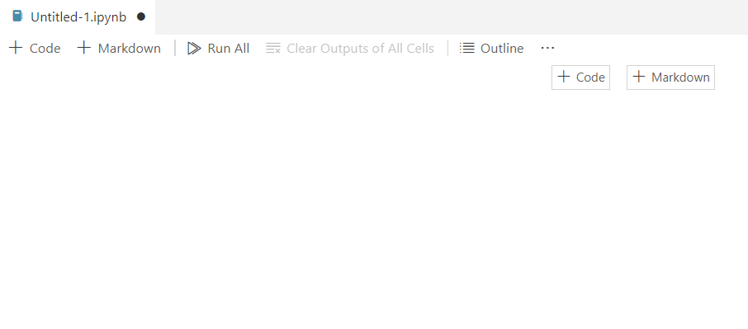
- To create a chunk of Python code click on “+ Code”. You will get an empty gray box which says Python on the lower-right corner.
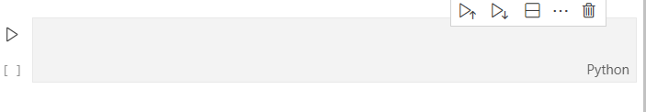
- Here you should enter the Python commands. For example, type the following line
print(“Hello World”)
- Nothing will happen until you run the program. Click on the arrow on the “play” button on the left-hand side of the box. You should see the message “Hello World” below the gray box. This is the output of the command.
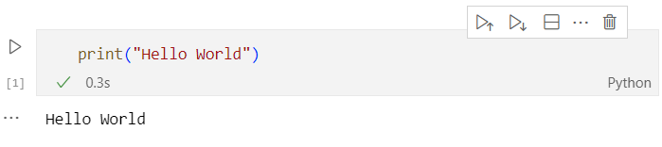

- One of the attractive features of Jupyter Notebooks is that you can add formatted text to describe what your code is doing. To add a chunk of text click on “+Markdown”. You will get a gray box that says “Markdown” in the lower-right corner.
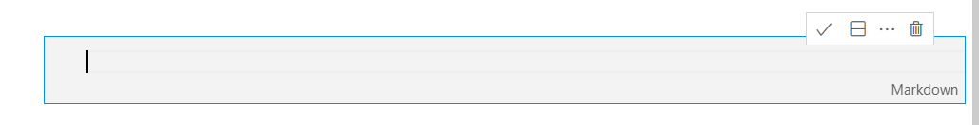
- Enter any phrase, e.g. “This is a verbal description”. To render the textbox, click on the CHECKMARK symbol in the top-right corner of the chunk. You can also render the textbox in the keyboard by holding the SHIFT key followed by the ENTER key. If you’re successful you will get an output that doesn’t have a gray background.
- To edit the markdown double click on the space where the text is. This should open the gray box again. To render the text box click on the CHECKMARK or do “SHIFT + ENTER” as before.
Example of Markdown Format:
Markdown is a language for formatted text. You can use different commands to make your notebook look prettier. You can see standard commands at
https://notebook.community/tschinz/iPython_Workspace/00_Admin/CheatSheet/Markdown%20CheatSheet
In the QTM class notes we use the following commands:
<span style="color:darkblue"> Lecture 1: Introduction to Jupyter Notebooks </span>

The content inside <span style="color:darkblue"> …. </span> has a particular format, in this case the option style, with dark blue color. Try changing it to red or green! We use <span> to start and </span> to end the segment that will have this format.
<font size="5">

We include this code at the beginning of the chunk, to ensure that all the text has size 5. Try other sizes!
<img src="figures/project_flow.png" width="650"/>

This code includes the figure “project_flow.png” in the subfolder “figures”. By default, the root folder is wherever the Python notebook is located. “width” is an option that specifies the number of pixels.
# Text
This writes the text in a bigger font as a “Header”. Check out the link above for more examples of Headers. You can combine it with other options like <span> </span> to create a header with a particular color.

